Digital Chip Design Program
RTL Design
Alia Alsultan
Elaf Alkhalaf
Lana Aldhali
Manar Alnuqaydan

Task #13
29/07/2026

Controller – Part 2

Task #13.1

13.1.1

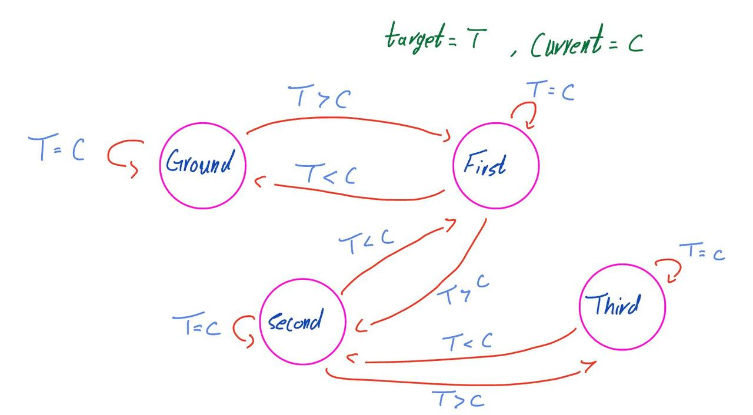

13.1.2

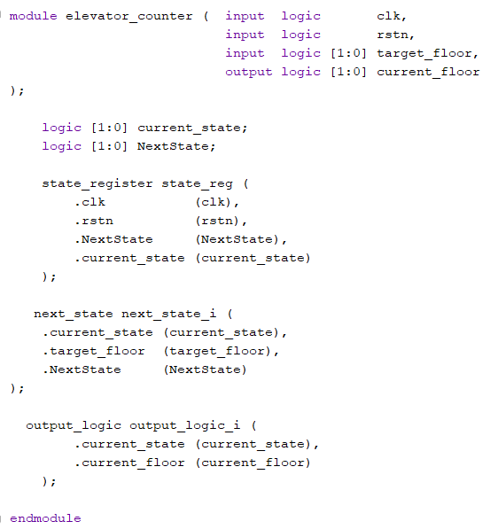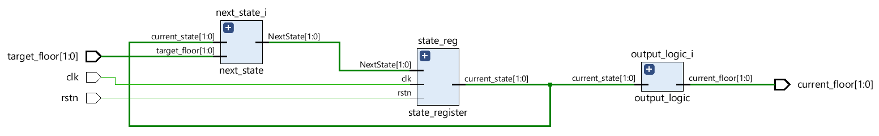

13.1.3

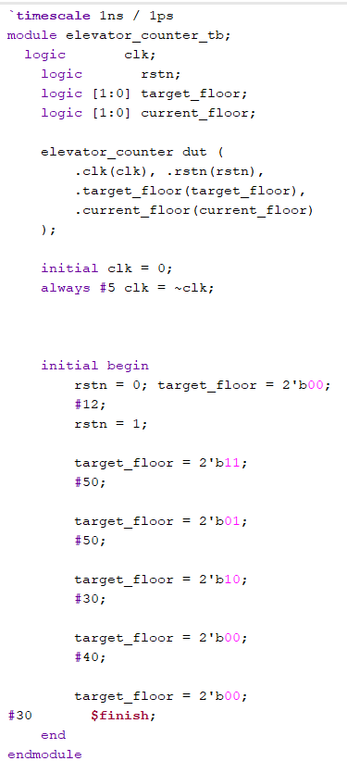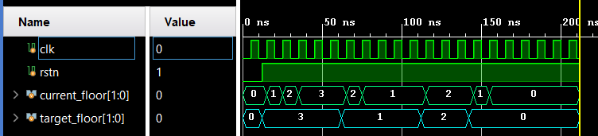

Work distribution

Section | Alia | Elaf | Lana | Manar
Report | ✔ | ✔ | ✔ | ✔
Task 13.1.1 | ✔ | ✔ | ✔ | ✔
Task 13.1.2 | ✔ | ✔ | ✔ | ✔
Task 13.1.3 | ✔ | ✔ | ✔ | ✔

